**PROJECT REPORT**

**Water Monitoring Boat**

by

Souradyuti Choudhury 20BCE1115

(souradyuti.choudhury2020@vitstudent.ac.in)

A project report submitted to

**Dr. Shola Usha Rani**

**SCOPE**

In fulfillment of the requirements for the course of

**IoT Domain Analyst**

**ECE3502**

In

**B.Tech Computer Science and Engineering**



**Vandalur – Kelambakkam Road**

**Chennai – 600127**

**Winter 2022-2023**

**ACKNOWLEDGEMENT**

We wish to express our sincere thanks and deep sense of gratitude to our project guide, **Dr. Shola Usha Rani,** School of Computer Science and Engineering for her consistent encouragement and valuable guidance offered to us throughout the course of the project work.

We are extremely grateful to **Dr. R. Ganesan, Dean,** School of Computer Science and Engineering (SCOPE), Vellore Institute of Technology, Chennai, for extending the facilities of the School towards our project and for his unstinting support.

We express our thanks to our **Head of the Department, Dr. Nithyanandanam P** for his support throughout the course of this project.

We also take this opportunity to thank all the faculty of the School for their support and their wisdom imparted to us throughout the courses.

We thank our parents, family, and friends for bearing with us throughout the course of our project and for the opportunity they provided us in undergoing this course in such a prestigious institution.

**TABLE OF CONTENTS**

|  |  |  |
| --- | --- | --- |
| **Ch. No** | **Chapter** | **Page Number** |
| 1 | Abstract | 4 |
| 2 | Introduction | 4 |
| 3 | Motivation | 5 |
| 4 | Objective | 5 |
| 5 | Summary | 6 |
| 6 | Literature Survey | 7 |
| 7 | Project Summary | 10 |
| 8 | Proposed System | 11 |
| 9 | Implementation Details | 13 |
| 10 | Result And Discussion | 16 |
| 11 | Conclusion | 21 |
| 12 | Future Work | 22 |
| 13 | References | 23 |
| 14 | Plagiarism Report | 25 |

**1.ABSTRACT**

Water monitoring systems on boats have gained significant attention in recent years due to their potential applications in various domains, ranging from environmental research to navigation and recreation. These systems leverage modern technologies such as IoT, cloud computing, sensors, and cameras to collect real-time data from the water body and transmit it to cloud-based platforms for analysis and visualization. In this project, we have developed a water monitoring system for boats using TDS sensors, temperature sensors (DS18B20), an ESP32-CAM Wi-Fi enabled camera, a Wi-Fi module, and motors for boat control. The collected data is sent to the AWS IoT platform, where it is stored and analyzed using AWS IoT Analytics and AWS QuickSight. The system aims to provide remote monitoring and analysis of water quality parameters and visual data of the water body, contributing to improved situational awareness and decision-making for boat operators and researchers.

**2.INTRODUCTION**

The water monitoring system designed for boats is an innovative project that utilizes sensors, cameras, and cloud technologies to provide real-time monitoring of water quality parameters and visual data of the water body. The system is designed to be efficient and scalable, enabling remote monitoring and analysis for various applications such as environmental research, and navigation.

One of the key features of the system is the use of Total Dissolved Solids (TDS) and temperature sensors (DS18B20) to monitor water quality parameters. These sensors can provide accurate and reliable data on the level of dissolved solids and temperature of the water, which are important indicators of water quality. The data collected by the sensors is transmitted to the cloud via AWS IoT, where it is stored and analyzed using AWS IoT Analytics and AWS QuickSight.

Another important feature of the system is the ESP32-CAM Wi-Fi enabled camera, which provides visual data of the water body. The camera can capture images and videos of the water body, which can be analyzed to identify patterns and trends in water quality parameters. The visual data can also be used for navigation purposes, enabling boat operators to identify potential hazards such as rocks or submerged objects.

The use of cloud technologies provides an efficient and scalable solution for data management and analysis. AWS IoT enables secure and scalable communication between devices and the cloud, while AWS IoT Analytics enables real-time data processing and analysis, and AWS QuickSight provides an intuitive and interactive platform for data visualization and exploration. The integration of IoT and cloud technologies enables efficient data collection, analysis, and visualization, enhancing situational awareness and decision-making for boat operators and researchers alike.

**3.MOTIVATION**

The main motivation behind this project is to provide a portable device for the user such as a farmer who can use it to collect data of a lake from all the points of water body and get the data about water and send it to cloud for analysis.

On the basis of analysis, user can get to know about the quality of water and can decide whether the water is suitable for use.

**4.OBJECTIVES**

The following are the objectives of the water monitoring system designed for boats:

1. Real-time monitoring of water quality parameters: The primary objective of the system is to provide real-time monitoring of water quality parameters such as Total Dissolved Solids (TDS) and temperature using sensors. The data collected by the sensors will be transmitted to the cloud via AWS IoT for storage and analysis.
2. Visual data of the water body: The system aims to provide visual data of the water body using an ESP32-CAM Wi-Fi enabled camera. The camera will capture images and videos of the water body, which can be analyzed to identify patterns and trends in water quality parameters.
3. Remote monitoring and analysis: The system is designed to enable remote monitoring and analysis of water quality parameters and visual data of the water body. The data collected by the sensors and camera will be transmitted to the cloud via AWS IoT, where it will be stored and analyzed using AWS IoT Analytics and AWS QuickSight.
4. Efficient data collection, analysis, and visualization: The integration of IoT and cloud technologies will provide an efficient and scalable solution for data collection, analysis, and visualization. The system will leverage the power of AWS IoT, AWS IoT Analytics, and AWS QuickSight to provide a robust and reliable cloud infrastructure for data management and analysis.

**5.SUMMARY**

Proposed System contains the flow diagram and the explanation of the architecture diagram.

Implementation details contains the modules, hardwares and softwares used and its use in our project.

Results and Discussion contains the screenshot of all analysis done, the photo of the boat and the user interface to control the boat.

**6.LITERATURE SURVEY**

Water quality monitoring is an important part of the transition towards intelligent and smart agriculture and provides an easy transition to automated monitoring of crucial components of human daily needs. To find trustworthy peer-reviewed publications, several digital databases were searched and examined, including IEEE Xplore®, ScienceDirect, Scopus, and Web of Science. Only 50 articles out of the 946 papers obtained were used in the study of the water quality monitoring research area. The criteria for inclusion for the second phase of filtration looked at the implementation of water quality monitoring and characterization procedures. Reviews and experimental studies comprised most of the articles, which were divided into three categories.

A taxonomy of the three literature was created to organize the literature into articles with similar types of experimental conditions. The investigation largely pointed out the problems in the accuracy of the models, the development of data-gathering systems, and the types of data used in the proposed frameworks. Finally, research directions towards smart water quality are presented. [1]

This paper presents a cost effective and efficient IoT based smart water quality monitoring system which monitors the quality parameters uninterruptedly. The developed model is tested with three water samples and the parameters are transmitted to the cloud server for further action. The paper proposes a cost effective and efficient IoT based smart water quality monitoring system which monitors the quality parameters uninterruptedly. The developed model is tested with three water samples and the parameters are transmitted to the cloud server for further action. [2]

One of the most vital natural resources is water. In homes, apartments, and workplaces, water is frequently and unintentionally squandered. This causes a shortage of water. Monitoring water levels is so crucial. As a result, less manpower, electricity, and water are wasted. One of the most crucial responsibilities of the process control engineer is level control. One of the most crucial applications in the chemical process industry, the food and beverage industry, the pharmaceutical industry, nuclear power plants, etc. is level control. Hence, in these sectors, it is necessary to maintain a steady fluid level while the fluid enters and exits the tank. Monitoring water quality is essential since it has an impact on aquatic life and human health. [3]

This paper presents a design and development of a low cost system for real time monitoring of the water quality in IOT (internet of things). The system consists of several sensors used to measure physical and chemical parameters of the water, such as temperature, PH, turbidity, and flow. The measured values can be processed by the core controller, the Arduino model, and the sensor data can be viewed on the internet using WI-FI system. Water pollution is a major concern for green globalization. [4]

"Design and Implementation of Wireless Sensor Network Based Water Quality Monitoring System" by R. Gnanasekaran, M. Umapathi, and N. Arunachalam: This research paper proposes a wireless sensor network-based water quality monitoring system that can measure pH, temperature, and turbidity in real-time. The system consists of sensor nodes that collect data and transmit it to a central node via wireless communication. The central node stores and analyzes the data, which can be accessed remotely.

"A Review of Water Quality Monitoring System Based on IoT Technology" by S. K. Kim, K. S. Hong, and S. J. Lee: This research paper provides a comprehensive review of water quality monitoring systems based on Internet of Things (IoT) technology. It covers various types of sensors, communication protocols, and data analysis techniques. The paper also discusses the challenges and future directions for IoT-based water quality monitoring systems.

"Smart Water Quality Monitoring System Using IoT" by R. Maheshwari, V. Sharma, and V. Singh: This research paper proposes a smart water quality monitoring system that uses IoT technology to monitor water quality parameters such as pH, turbidity, and dissolved oxygen. The system uses a microcontroller-based circuit to collect data from sensors and sends it to a cloud server for analysis. The authors also discuss the advantages and challenges of using IoT technology for water quality monitoring.

"Development of a Portable Water Quality Monitoring System for Field Analysis" by H. A. Ali, A. F. N. Abdullah, and N. A. Aziz: This research paper describes the development of a portable water quality monitoring system that can be used for field analysis. The system measures parameters such as pH, conductivity, and total dissolved solids (TDS) using sensors and displays the results on a LCD screen. The authors also discuss the importance of field analysis for water quality monitoring.

"Water Quality Monitoring System Based on IoT and Artificial Intelligence" by D. S. Kim, S. H. Jeong, and J. W. Kim: This research paper proposes a water quality monitoring system that uses IoT technology and artificial intelligence (AI) to monitor water quality parameters such as pH, turbidity, and dissolved oxygen. The system uses machine learning algorithms to predict the water quality level and sends alerts to users if it falls below a certain threshold. The authors also discuss the potential of using AI for water quality monitoring and the challenges of integrating IoT and AI technologies.

"Development of an Autonomous Robotic Boat for Water Quality Monitoring" by K. M. Chua, W. W. Loh, and C. M. Ho: This research paper presents the design and development of an autonomous robotic boat that can carry out water quality monitoring tasks. The boat is equipped with sensors to measure parameters such as pH, temperature, and dissolved oxygen. It can navigate autonomously using GPS and compass sensors. The authors also discuss the challenges of developing an autonomous robotic boat for water quality monitoring.

"An Autonomous Surface Vessel for Coastal Water Quality Monitoring" by D. Alves, C. H. Cunha, and J. Pinto: This research paper presents an autonomous surface vessel for coastal water quality monitoring. The vessel is equipped with a suite of sensors to measure parameters such as salinity, temperature, and turbidity. It can navigate autonomously using a GPS system and communicate data to a remote station. The authors also discuss the advantages of using an autonomous vessel for water quality monitoring.

"Development of an Autonomous Water Quality Monitoring Robot" by S. K. Kim, K. J. Kwon, and J. H. Kim: This research paper describes the development of an autonomous water quality monitoring robot that can measure parameters such as pH, temperature, and turbidity. The robot is designed to navigate in shallow water and can communicate data wirelessly to a remote station. The authors also discuss the challenges of developing an autonomous robot for water quality monitoring.

"Design of an Unmanned Surface Vehicle for Water Quality Monitoring" by A. S. Shams, S. M. Shafiul Alam, and M. S. Alam: This research paper presents the design of an unmanned surface vehicle for water quality monitoring. The vehicle is equipped with sensors to measure parameters such as pH, dissolved oxygen, and conductivity. It can navigate autonomously using GPS and can be controlled remotely. The authors also discuss the potential applications of using unmanned vehicles for water quality monitoring.

"Development of an Autonomous Robotic Boat for Real-Time Water Quality Monitoring" by M. P. Neethu, R. P. Menon, and R. R. Nair: This research paper presents the development of an autonomous robotic boat for real-time water quality monitoring. The boat is equipped with sensors to measure parameters such as pH, turbidity, and dissolved oxygen. It can navigate autonomously using GPS and can communicate data wirelessly to a remote station. The authors also discuss the advantages of using autonomous boats for water quality monitoring, such as cost-effectiveness and improved accuracy.

**7. PROJECT SUMMARY**

We will be using mainly two sensors to determine water quality, we will include a TDS sensor as well as a temperature sensor. These sensors will detect the presence of suspended particles in the water. We also have a camera module which will help to navigate the boat.

Thus the water quality monitoring boat can be used for water quality monitoring on lakes and reservoirs with ease.

We also have an interface to control the boat using L298N motor driver and DC motors to rotate the propeller to make the boat move. ESP32 is used to control the boat.

**8.PROPOSED SYSTEM**

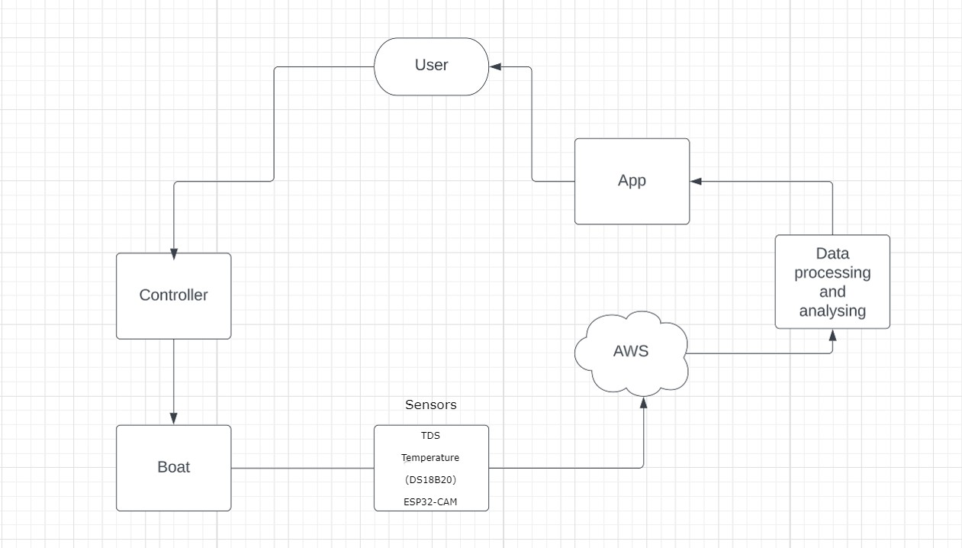

User Interface: The user would interact with a mobile app, which acts as a controller for the boat. The user could control the movement of the boat through the app, sending commands to the motor driver L298N to control the motors on the boat for forward, backward, left, or right movements.

Sensor Data Collection: The TDS sensor, temperature sensor DS18B20, and camera ESP32-CAM would collect data from the water body being monitored.

Data Transmission: The collected data from the TDS sensor, temperature sensor, and camera module would be transmitted to the AWS IoT cloud platform for further processing and analysis. This could be achieved through Wi-Fi or other communication protocols supported by the devices and AWS IoT, such as MQTT or HTTP.

Motor Control: The motor driver L298N would receive commands from the mobile app via the AWS IoT platform, and control the motors on the boat accordingly. The motor driver L298N would convert the commands into appropriate signals to control the motors, allowing the boat to move in the desired direction.

Data Processing: AWS IoT would receive the sensor data transmitted from the TDS sensor, temperature sensor, and camera module, as well as the commands for motor control. AWS IoT Analytics would process the data, as per the configured data processing workflows. For example, the sensor data could be normalized, aggregated, or enriched with other data sources, and the motor control commands could be analyzed to identify patterns or anomalies.

Data Storage: The processed data would be stored in AWS IoT Analytics or other AWS data storage services, such as Amazon S3 or Amazon DynamoDB, for long-term storage and historical analysis. The data could be stored in a structured or unstructured format, depending on the requirements of the project.

Data Visualization: AWS QuickSight could be used to create interactive and visually appealing dashboards and reports that visualize the processed data, including the sensor data and motor control commands, in a meaningful way. The data could be visualized as charts, graphs, maps, or other graphical representations, allowing stakeholders to easily understand and interpret the data, and monitor the boat's movements in real-time.

Monitoring and Alerts: The system could be configured to generate alerts or notifications based on predefined rules or thresholds. For example, if the sensor data indicates poor water quality or abnormal temperature levels, an alert could be sent to designated stakeholders via email, SMS, or other communication channels. Similarly, if there are issues with motor control or communication with the app, alerts could be generated for troubleshooting and resolution.

**9. IMPLEMENTATION DETAILS**

**9.1 Module Details**

* TDS sensor

TDS stands for Total Dissolved Solids. TDS sensors are used to measure the concentration of dissolved solids in water, which can give an indication of water quality. In the project, the TDS sensor is likely used to measure the level of dissolved solids in the water body being monitored by the system.

* Temperature sensor(DS18B20)

The DS18B20 is a digital temperature sensor that provides accurate temperature readings. It is often used in projects where precise temperature monitoring is required. In this project, the DS18B20 temperature sensor may be used to measure the water temperature in the monitored water body.

* ESP32 wificam

The ESP32-CAM is a popular development board that integrates an ESP32 microcontroller with a camera module. It allows for capturing images or video and transmitting them over Wi-Fi. In the project, the ESP32-CAM camera module is likely used to capture images or video of the monitored water body, allowing visual monitoring of the water conditions.

* Nodemcu (ESP8266)

ESP8266 NodeMCU is a popular development board based on the ESP8266 microcontroller. The ESP8266 is a low-cost Wi-Fi microchip with full TCP/IP stack and microcontroller capabilities, making it ideal for IoT projects.The NodeMCU board features a built-in USB-to-serial converter for easy programming and debugging, and it can be programmed using the Arduino IDE or Lua scripting language. It also includes a 3.3V regulator and a breadboard-friendly design, making it easy to prototype with.

* L298N Motor Driver

The L29N8 motor driver is a popular integrated circuit (IC) commonly used for driving DC motors in robotics, automation, and other electro-mechanical applications. It is a dual H-bridge motor driver, capable of controlling two DC motors independently or a single stepper motor. The L29N8 motor driver is known for its versatility, ease of use, and robustness, making it a popular choice among hobbyists, DIY enthusiasts, and professional engineers alike.

**9.2 Hardware Details**

* Rudder/Propeller
* Battery
* BreadBoard
* Jumper Wires

**9.3 Software Details**

* Arduino

The Arduino software includes a text editor with syntax highlighting and code completion features, making it easier to write and debug code. It also includes a serial monitor for debugging and testing, and allows users to upload the compiled code to the Arduino board through a USB connection.

* AWS Iot Core

AWS IoT is a cloud-based platform provided by Amazon Web Services (AWS) for building and managing Internet of Things (IoT) applications. It provides services for securely connecting, managing, and analyzing IoT devices and their data. In this project, AWS IoT is likely used for connecting and managing the TDS sensor, temperature sensor, and camera module, enabling data transmission and analysis in the cloud.Sensor data is published using MQTT.

* Aws Iot Analaytics

AWS IoT Analytics is a service provided by AWS for processing, storing, and analyzing large volumes of IoT data. It offers features such as data ingestion, data processing, data storage, and data visualization for IoT applications. In the project, AWS IoT Analytics may be used for processing and analyzing the data collected from the TDS sensor, temperature sensor, and camera module, enabling insights and actionable information for monitoring the water body.

* Aws Iot Quicksight

AWS QuickSight is a business intelligence (BI) and data visualization service provided by AWS. It allows for creating interactive and visually appealing dashboards and reports from various data sources, including IoT data. In the project, AWS QuickSight may be used for visualizing and presenting the data collected from the TDS sensor, temperature sensor, and camera module in the form of graphical dashboards or reports, making it easier to interpret and understand the data.

**9.4 User Interface**

* Mobile

Used to check the graph obtained after anaylsis on AWS quicksight dashboard in app.

Also used to control the boat.

**10. RESULT AND DISCUSSION**

**10.1 Interface of controlling the boat:**

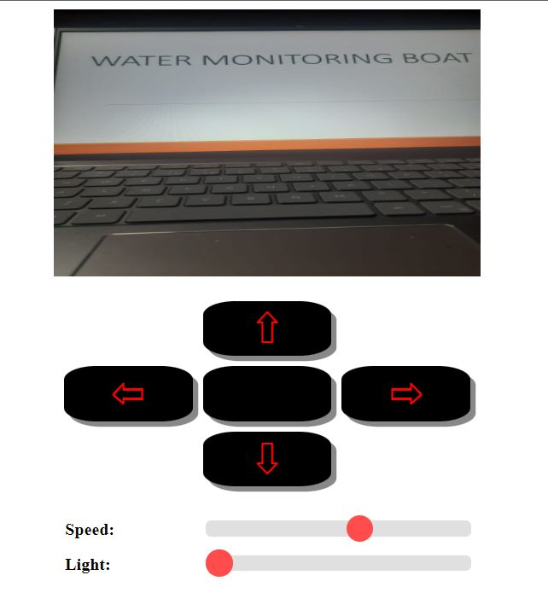

**10.2 Screenshots of Boat during test run:**

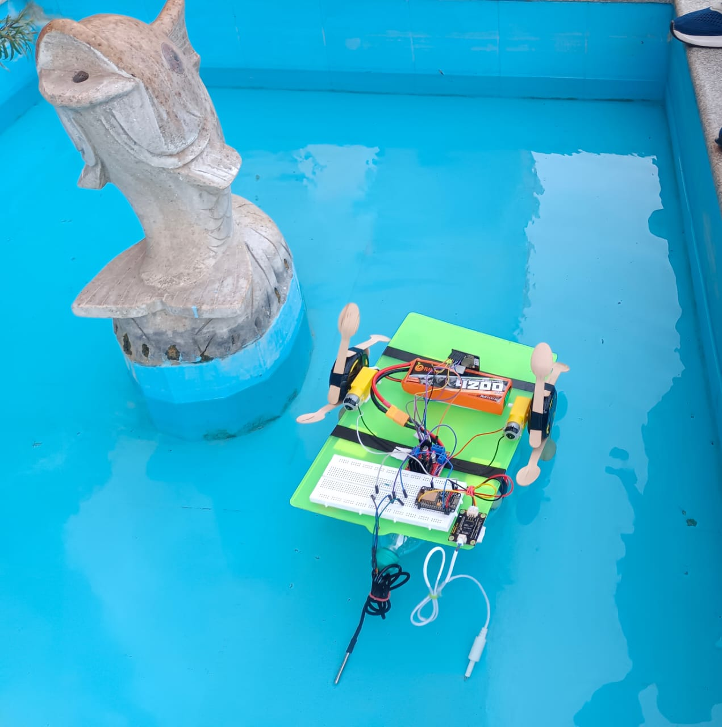

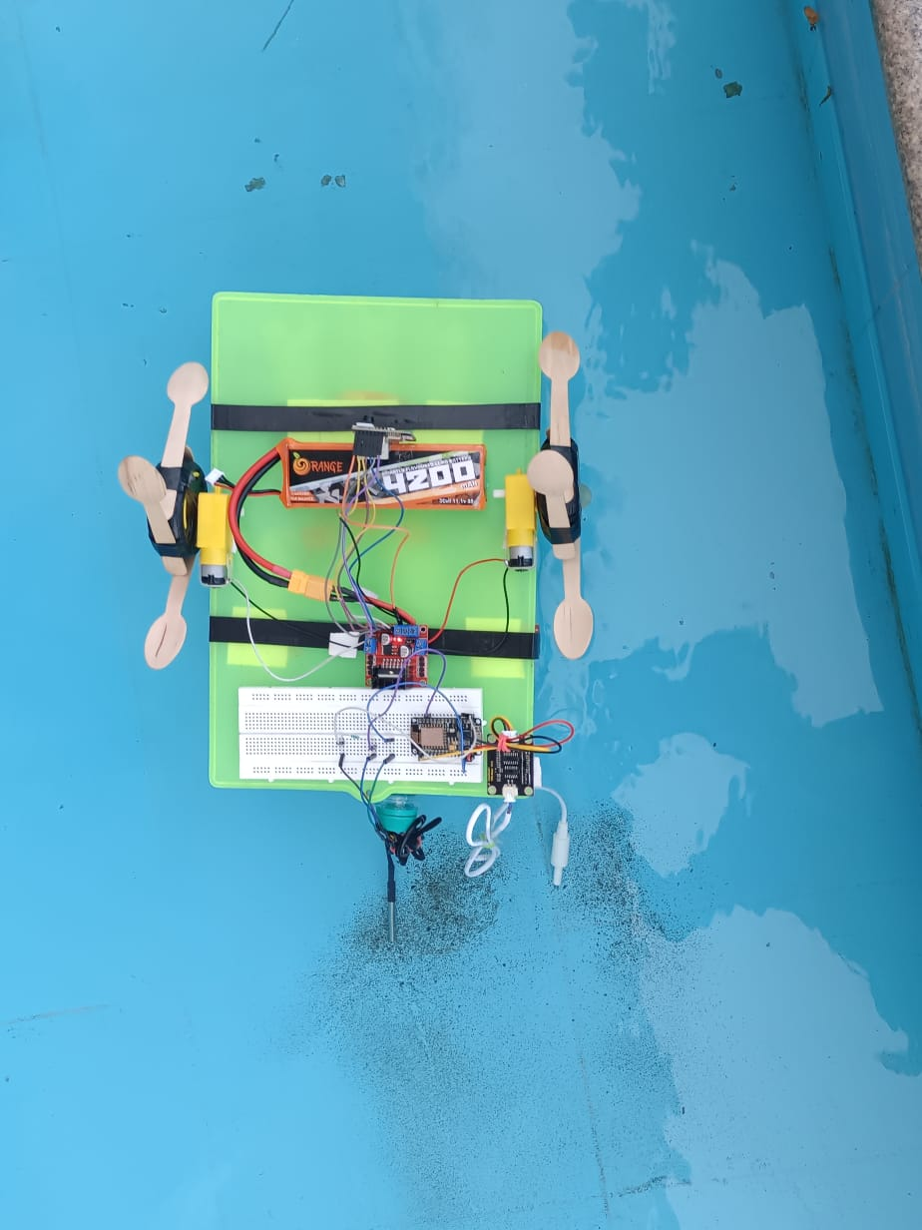

**10.3 Analysis of Data collected by our Water Monitoring System:**

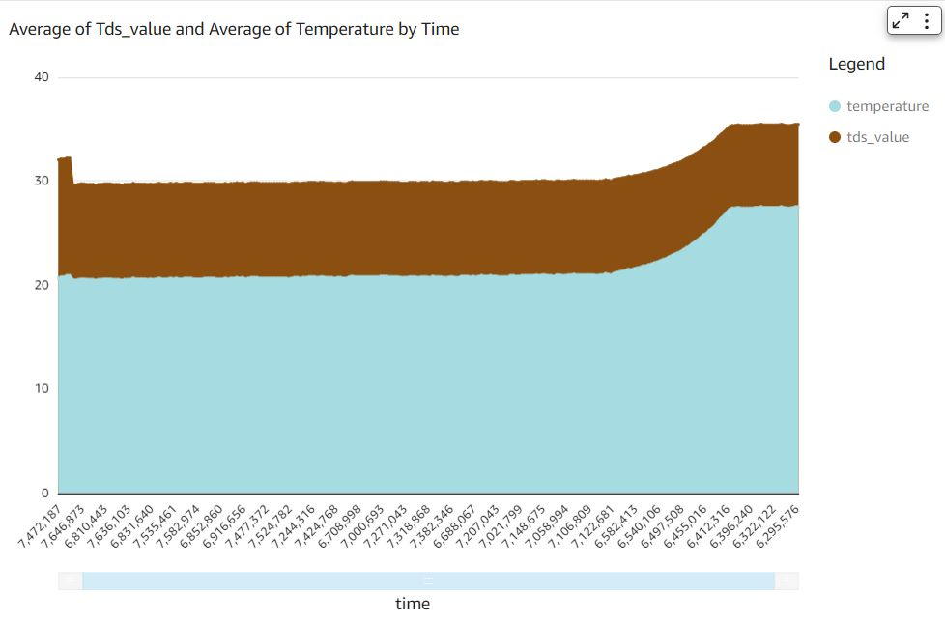

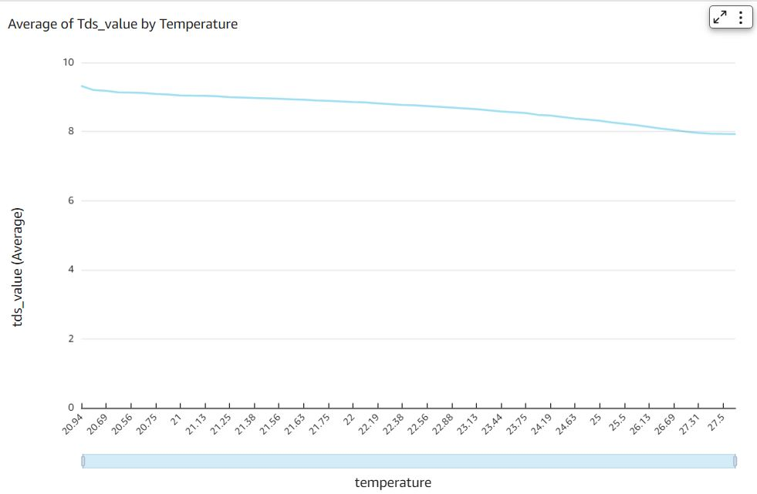

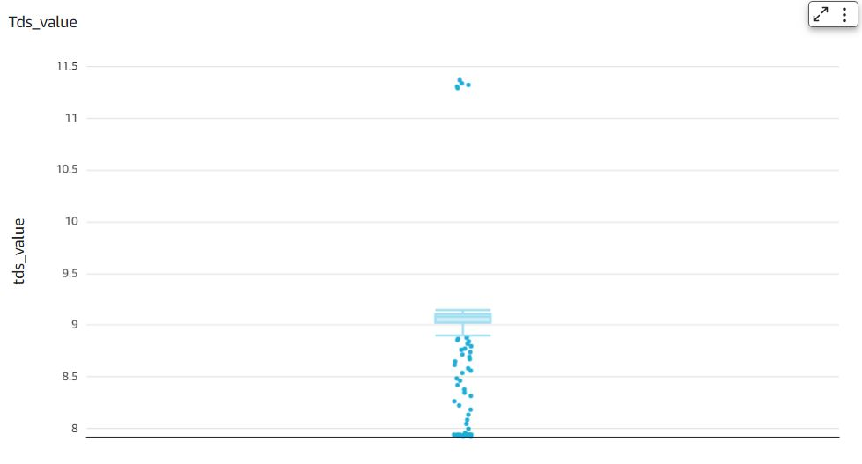

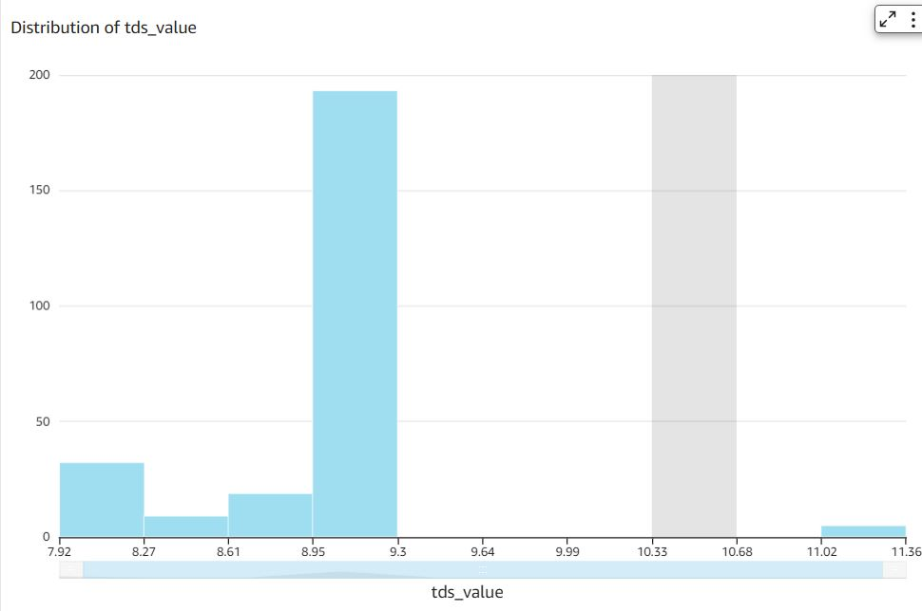

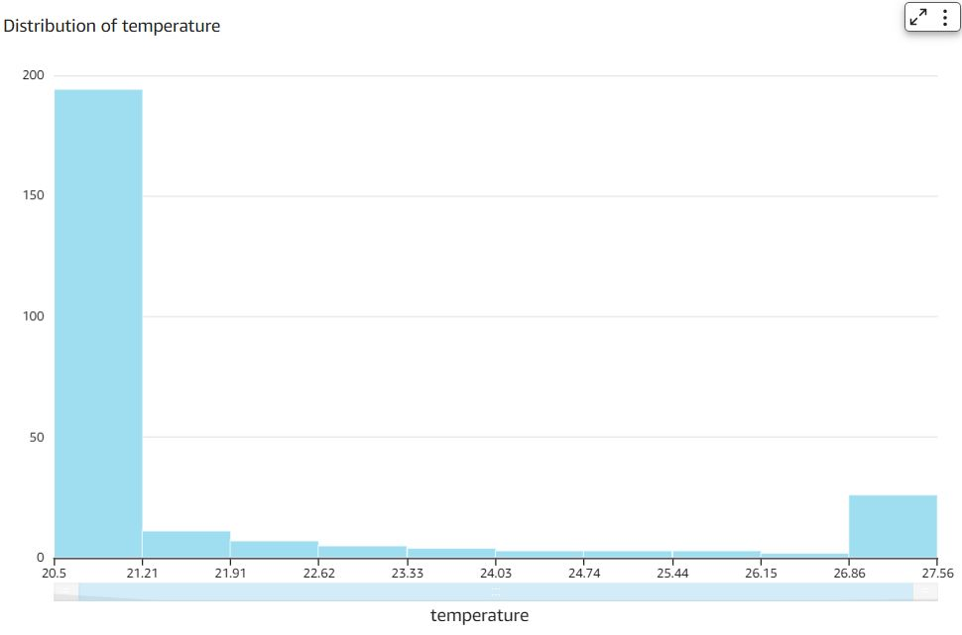

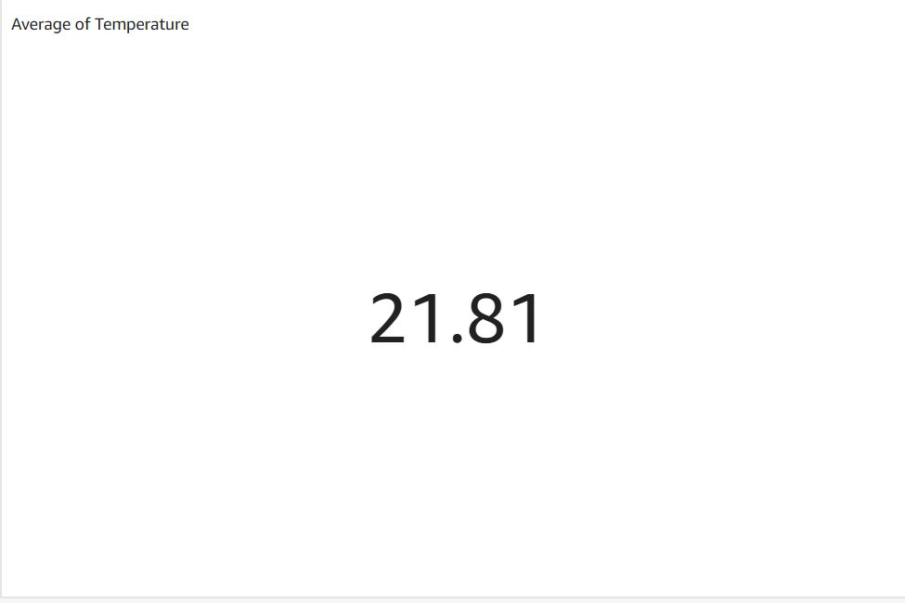

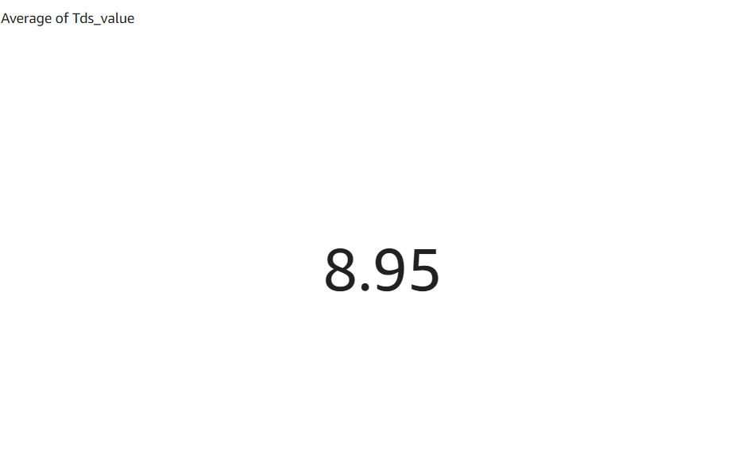

**11.CONCLUSION**

In conclusion, the proposed water monitoring system on a boat, utilizing TDS sensors, temperature sensors, a camera, cloud-based platforms, and boat control, presents a comprehensive and innovative approach for real-time water monitoring and analysis. The integration of multiple sensors and cloud-based analytics allows for continuous monitoring of water quality parameters, while the camera provides visual data of the water body. The use of cloud-based platforms enables data storage, analysis, and visualization, providing users with valuable insights into water quality trends and changes.

The proposed system has the potential to find applications in various domains, such as environmental monitoring, navigation, and recreational activities. It can aid in early detection of water quality issues, allowing for timely actions to be taken to mitigate potential risks. Additionally, the system can provide valuable data for research purposes, supporting scientific studies related to water quality and environmental health.

However, there are challenges that need to be addressed, such as power management for prolonged system operation on a boat, robust data transmission in varying environmental conditions, and system reliability for long-term deployment. Further research and development efforts may be required to optimize the system's performance and address these challenges.

Overall, the proposed water monitoring system on a boat has the potential to enhance water quality monitoring capabilities in boat-based scenarios, providing valuable insights and supporting decision-making for better management of water resources.

**12.FUTURE WORK**

Sensors to collect data about pH sensors, Dissolved oxygen can be added to the boat to give more details about water. The boat can also be waterproofed and using more powerful motor can be used as a submarine to go into dept and navigate at bottom of lake as well to collect data.

Algorithms can be used to detect object and driver assistance to prevent the boat from colliding into object.

The data collected by the water monitoring system could be integrated with water treatment systems to enhance their efficiency and effectiveness. This could be particularly useful in areas where access to clean water is limited.

**12.REFERENCES**

[1] Zulkifli, C. Z., Garfan, S., Talal, M., Alamoodi, A. H., Alamleh, A., Ahmaro, I. Y., ... & Chiang, H. H. (2022). IoT-Based Water Monitoring Systems: A Systematic Review. *Water*, *14*(22), 3621.

[2] Lakshmikantha, V., Hiriyannagowda, A., Manjunath, A., Patted, A., Basavaiah, J., & Anthony, A. A. (2021). IoT based smart water quality monitoring system. *Global Transitions Proceedings*, *2*(2), 181-186.

[3] Rakshitha, M. R., & Maheshan, C. M. (2020). A review on water level & quality monitoring system. *International Journal of Engineering Research & Technology (IJERT)*, *8*(14), 78-80.

[4] Daigavane, V. V., & Gaikwad, M. A. (2017). Water quality monitoring system based on IoT. *Advances in wireless and mobile communications*, *10*(5), 1107-1116.

[5] R. P. N. Budiarti, A. Tjahjono, M. Hariadi and M. H. Purnomo, "Development of IoT for Automated Water Quality Monitoring System," 2019 International Conference on Computer Science, Information Technology, and Electrical Engineering (ICOMITEE), Jember, Indonesia, 2019, pp. 211-216, doi: 10.1109/ICOMITEE.2019.8920900.

[6] Q. BAI, J. Wu and C. JIN, "The Water Quality Online Monitoring System Based on Wireless Sensor Network," 2020 13th International Symposium on Computational Intelligence and Design (ISCID), Hangzhou, China, 2020, pp. 234-237, doi: 10.1109/ISCID51228.2020.00059.

[7] M. E. Ramadani, B. Raafi’u, M. Mursid, R. H. Ash-Shiddieqy, A. T. Zain and A. Fauzan ‘Adziimaa, "Design and Development Of Monitoring System On Carp Farming Ponds As IoT- Based Water Quality Control," 2021 3rd International Conference on Research and Academic Community Services (ICRACOS), Surabaya, Indonesia, 2021, pp. 148-153, doi: 10.1109/ICRACOS53680.2021.9701980.

[8] C. Feng, J. Yuan, Y. Sun and J. You, "Design of Water Quality Monitoring System," 2020 International Conference on Artificial Intelligence and Computer Engineering (ICAICE), Beijing, China, 2020, pp. 264-267, doi: 10.1109/ICAICE51518.2020.00057.

[9] C. Zhang, J. Wu and J. Liu, "Water quality monitoring system based on Internet of Things," 2020 3rd International Conference on Electron Device and Mechanical Engineering (ICEDME), Suzhou, China, 2020, pp. 727-730, doi: 10.1109/ICEDME50972.2020.00171.

[10] M. Noorizadeh and N. Meskin, "Design of small autonomous boat for course-keeping manuevers," 2017 4th International Conference on Control, Decision and Information Technologies (CoDIT), Barcelona, Spain, 2017, pp. 0908-0912, doi: 10.1109/CoDIT.2017.8102712.

[11] T. -H. Tran and T. -L. Le, "Vision based boat detection for maritime surveillance," 2016 International Conference on Electronics, Information, and Communications (ICEIC), Danang, Vietnam, 2016, pp. 1-4, doi: 10.1109/ELINFOCOM.2016.7563033.

[12] M. A. H. Tarif, Z. Z. Zakaria, D. S. Laila, M. A. M. Sarbini and S. R. Ya’Akub, "Design and Control of an Autonomous Electric Catamaran Boat," 2022 International Conference on Green Energy, Computing and Sustainable Technology (GECOST), Miri Sarawak, Malaysia, 2022, pp. 75-80, doi: 10.1109/GECOST55694.2022.10010362.

[13] J. Satheesh, A. P. Nair, D. M., C. A., G. Mahesh and P. R. Jayasree, "Wireless Communication based Water Surface Cleaning Boat," 2020 4th International Conference on Trends in Electronics and Informatics (ICOEI)(48184), Tirunelveli, India, 2020, pp. 716-720, doi: 10.1109/ICOEI48184.2020.9142960.

[14] V. Lisena, M. Paschero, V. Gentile, P. Amicucci, A. Rizzi and F. M. F. Mascioli, "A new method to restore the water quality level through the use of electric boats," 2016 IEEE International Smart Cities Conference (ISC2), Trento, Italy, 2016, pp. 1-4, doi: 10.1109/ISC2.2016.7580870.

Plagiarism Score as generated by Quill Bot

